

A Project Report On

**Hotel Management System**

Hospital

By Hithai Shree J

Prasanna Lakshmi Anuhya Muddanur Mounika K

Under the Guidance of,

**Mamta Boga**

**Technical Trainer**

**EduBridge**

(School of Coding )

### ABSTRACT

In this Project we aim to solve the traditional issues of hospital management. The existing system provided paper based solution for keeping records of patients and hospital staff, but it gives overload to Doctor, Receptionist and Administrator. The main issues were inappropriate data keeping, time wastage in storage, retrieval also patients were unable to understand the prescription etc.

These issues are solved by providing a separate user account for doctors and other staff. Keeping each patient’s data separate and track previous visits in a single click.

This project uses MYSQL as backend and is developed in Java so it provides features such as platform independence, high performance and security. It is a web application which mainly uses Spring Boot and Hibernate frameworks.

It provides some enhanced features such as: an easy interface to add, remove Users, Doctors as well and it provides to check appointment. Thus, Keeps each patient’s data separate, easy to track.

## Introduction

Human Body is a very complex and sophisticated structure and comprises of millions of functions. All these complicated functions have been understood by man, part-by-part through their research and experiments.

As science and technology progressed, medicine became an integral part of the research.

Gradually, medical science became an entirely new branch of science. As of today, the Health Sector comprises of Medical institutions i.e. Hospitals, research and development institutions and medical colleges.

Thus the Hospital management system aims at providing the best medical facilities to the common man needs.

### Existing System :

* The Existing system was paper-based.
* keeping track of all the activities (like records of its patients, doctors and other staff personals) and their records on paper is very cumbersome and error prone.
* It was very inefficient and a time-consuming process Observing the continuous increase in population and number of people visiting the hospital. Recording and maintaining all these records on paper was highly unreliable, inefficient and error-prone.
* It is too slow and cannot provide updated lists of required things within reasonable timeframe.
* It is also not economically & technically feasible to maintain these records on paper.

### Existing System Drawbacks :

* Chances of data loss and inadequacy.
* Too slow and cannot provide updated lists of patients within reasonable timeframe.
* Also, management of Hospital was cumbersome and error prone .
* Modifying previous mistakes wasn't easy.
* No reliable storage and backup facilities.
* It is also not economically & technically feasible to maintain these records on paper.

### Proposed System :

Hospital are the essential part of our lives, providing best medical facilities to people suffering from various ailments, which may be due to change in climatic conditions, increased work-load, emotional trauma, stress etc. It is necessary for the hospitals to keep track of its day-to-day activities & records of its patients, doctors that keep the hospital running smoothly & successfully. Our objective is to digitalize all the version of the manual system,and we named it as “Hospital Management System”.

The main aim of our project is to provide a paper-less hospital up to 90%. It also aims at providing low-cost reliable digitalization of the existing systems. The proposed system also provides excellent security of data at every level of user-system interaction and also provides robust & reliable storage facility. The purpose of this project is to digitalize, the process of day-to-day activities like Registering New Patient, Assigning a Doctor to new patient, Adding new staff members, and finally compute the bill etc.

As the proposed software product is the Hospital Management system (HMS). The system will be used in any hospital, clinic etc. Hospitals (small to medium scale) can used it to to get the information from the patients and then storing that data for future usages. The intention of the system is to reduce over-time pay and increase the number of patients that can be treated accurately. Requirement statements in these documents are both functional and non-functional.

we have tried best to make the complicated process Hospital Management System as simple as possible using Structured & Modular technique & Menu oriented interface. We have tried to design the software in such a way that doctor may not have any difficulty in using this package & further expansion is possible without much effort. Even though we cannot claim that this work to be entirely exhaustive, the main purpose of us exercise is perform Hospital’s activity in computerized way rather than manually which is time consuming. We are confident that this software package can be readily used by non- programming personal avoiding human handled chance of error.

## Software Requirement & Adapted Methodologies

### Software Requirement Specification:

The software requirement specification is produced at the culmination of the analysis task. The function and performance allocated to software as part of system engineering are redefined by establishing a complete information description as functional requirement, a representation of system behaviour, an indication of performance requirement and design constraints, appropriate validation criteria.

### IDE Used:-

* + Eclipse is a widely used IDE primarily for Java development. Eclipse is used for C and C++ development as well as PHP among other programming languages
  + Eclipse IDE is written in Java. It mainly consists of a base ‘Workspace’ and a plug-in system so that we can add more features to it through plugins and extend the functionality of the IDE.
  + Eclipse works on all the major platforms including Windows, Mac OS, Linux, etc. and boasts of powerful features that can be used to develop full-fledged projects.

### Features Of Eclipse IDE:

* + Almost everything in Eclipse is a plugin.
  + We can extend the functionality of Eclipse IDE by adding plugins to the IDE, maybe for additional programming language or version control system or UML.
  + Supports various source knowledge tools like folding and hyperlink navigation, grading, macro definition browser, code editing with syntax highlighting.
  + Provides excellent visual code debugging tool to debug the code.
  + Eclipse has a wonderful user interface with drag and drop facility for UI designing.
  + Supports project development and administered framework for different toolchains, classic make framework, and source navigation.
  + Java Eclipse IDE has a JavaDoc facility using which we can automatically create documentation for classes in our application.

Edu Bridge 5

### Development Environment for Eclipse includes:

* Eclipse Java Development Tools (JDT) for Java and Scala.
* Eclipse C/C++ Development Tools (CDT) for C/C++.
* Eclipse PHP Development Tools (PDT) for PHP.

### Server Used :

Tomcat is a popular web container software designed to execute Java servlets and render web pages that use Java Server page coding. Accessible as either a binary or a source code version. Tomcat’s been used to power a wide range of applications and websites across the Internet. Atthis time, it’s definitely one of the more popular servlet containers available**.**

### Features:

1. **Incredibly Lightweight**:-

Even with Java EE certification, Tomcat is an incredibly lightweight application.If offers only the most basic functionality necessary to run a server, meaning it provides relatively quick load and redeploy times compared to many of its peers, which are bogged down with far too many bells and whistles. This lightweight nature also allows it to enjoy a significantly faster development cycle.

### Open-Source-

It is an open source Server which means it is free of cost. Tomcat’s free, and the source code for the server is readily available to anyone who’d care to download it. What this means is that – assuming you’re willing to tinker with the moving parts of your server – you’ve got an incredible degree of freedom insofar as what you want to do with a Tomcat installation.

### Highly Flexible

Thanks to its lightweight nature and a suite of extensive, built-in customization options, Tomcat is quite flexible. You can run it in virtually any fashion you choose, and it’ll still work as intended. The fact that it’s open-source helps as well, since you can tweak it to fit your needs, provided you’ve the knowledge to do so.

Edu Bridge 6

### Language Used:-

The Java programming language is designed to meet the challenges of application development in the context of heterogeneous, network-wide distributed environments.

Paramount among these challenges is secure delivery of applications that consume the minimum of system resources, can run on any hardware and software platform, and can be extended dynamically.

The Java programming language originated as part of a research project to develop advanced software for a wide variety of network devices and embedded systems.

Java has proven ideal for developing secure, distributed, network-based end-user applications in environments ranging from network-embedded devices to the World-Wide Web and the desktop.

### Frameworks Used:-

1. **Hibernate:-**
   * Hibernate is an open source Java persistence framework project.
   * It performs powerful Object-relational mapping and query databases using HQL and SQL.
   * Hibernate is a great tool for ORM mappings in Java. It can cut down a lot of complexity and thus defects as well from your application, which may otherwise find a way to exist.
   * This is especially boon for developers with limited knowledge of SQL.

### Hibernate Architecture

#### Configuration :

In hibernate.properties or hibernate.cfg.xml files. For Java configuration, you may find class annotated with @Configuration. It is used by SessionFactory to work with Java Application and the Database. It represents an entire set of mappings of an application Java Types to an SQL database.

#### Session Factory :

Any user application requests Session Factory for a session object. Session Factory uses configuration information from above listed files, to instantiates the session object appropriately.

Edu Bridge 7

#### Session :

This represents the interaction between the application and the database at any point of time. This is represented by the org.hibernate.Session class. The instance of a session can be retrieved from the SessionFactory bean.

#### Query :

It allows applications to query the database for one or more stored objects. Hibernate provides different techniques to query database, including NamedQuery and Criteria API.

#### First-level cache :

It represents the default cache used by Hibernate Session object while interacting with the database. It is also called as session cache and caches objects within the current session. All requests from the Session object to the database must pass through the first-level cache or session cache. One must note that the first-level cache is available with the session object until the Session object is live.

#### Transaction :

Enables you to achieve data consistency, and rollback incase something goes unexpected.

* 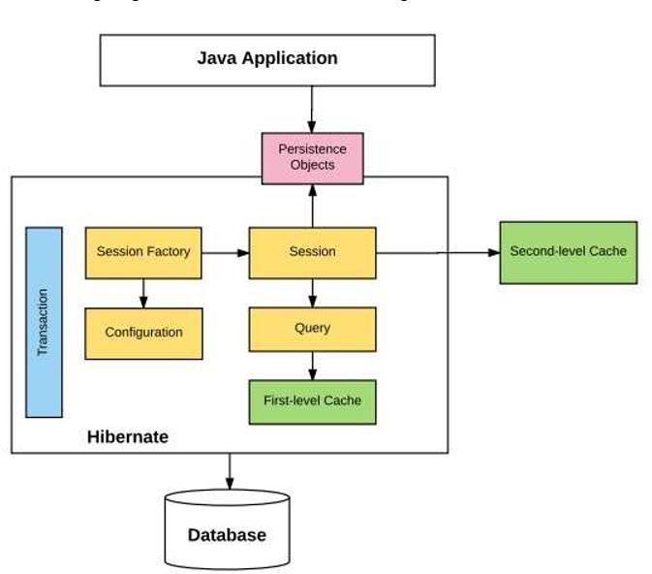The following diagram summarizes the main building blocks in hibernate architecture.

#### Fig. Hibernate Architecture

Edu Bridge 8

### Why to use Hibernate technology –

* + Hibernate supports Inheritance, Associations, Collections.
  + In hibernate if we save the derived class object, then its base class object will also be stored into the database, it means hibernate supporting inheritance
  + Hibernate supports relationships like One-To-Many,One-To-One, Many-To-Many-to Many, Many-To-One
  + This will also supports collections like List,Set,Map (Only new collections)
  + In jdbc all exceptions are checked exceptions, so we must write code in try, catch and throws, but in hibernate we only have Un-checked exceptions, so no need to write try, catch, or no need to write throws. Actually in hibernate we have the translator which converts checked to Un-checked
  + Hibernate has capability to generate primary keys automatically while we are storing the records into database
  + Hibernate has its own query language ,i.e hibernate query language which is database independent
  + Hibernate supports annotations, apart from XML
  + So if we change the database, then also our application will works as HQL is database independent.

### Spring Boot:-

* **Advantages Of Spring Boot Framework:-**

1. **Separate roles** - The Spring MVC separates each role, where the model object, controller, command object, view resolver, DispatcherServlet, validator, etc. can be fulfilled by a specialized object.
2. **Light-weight** - It uses light-weight servlet container to develop and deploy your application.
3. **Powerful Configuration** - It provides a robust configuration for both framework and application classes that includes easy referencing across contexts, such as from web controllers to business objects and validators.
4. **Rapid development** - The Spring MVC facilitates fast and parallel development.
5. **Reusable business code** - Instead of creating new objects, it allows us to use the existing business objects.
6. **Easy to test** - In Spring, generally we create JavaBeans classes that enable you to inject test data using the setter methods.
7. **Flexible Mapping** - It provides the specific annotations that easily redirect the page.

### Browser Used:- Google Chrome Features:

1. **Task manager:-**
   * Chrome has its own Task Manager that shows you how much memory and CPU usage each tab and plug-in is using.
   * You can open it by clicking Shift-Esc from within Chrome.
   * You can get more details by clicking the "Stats for nerds" link on the Task Manager and it will open a page with a full breakdown of memory and CPU usage for each process within the browser.

### Upgraded tabs:-

* + The Chrome development team views tabs as one of the best new innovations to Web browsing in recent years and so they wanted to expand the functionality of tabs since users .
  + In Chrome you can drag a tab into its own window, and drag it back to the main window. This is called "Dynamic Tabs." Also, by default, the "New Tab" page in Chrome features a page that shows thumbnails of your most visited Web sites, a list of your recent bookmarks, and a search box that allows you to search your history.

### Hardware Specification:-

|  |  |
| --- | --- |
| **Content** | **Description** |
| Processors | i3,i5,i7 |
| Hard Drive | 1GB(minimum) 2GB(Recommended) |
| RAM | 512MB(minimum) 1GB(Recommended) |

|  |  |
| --- | --- |
| Operating System | Windows 10,Windows 7,Windows 8 |

**Database and other software specification:-**

|  |  |
| --- | --- |
| **Content** | **Description** |
| Language | HTML, JAVA, JAVASCRIPT,CSS |
| Database | MySQL |
| Framework | Hibernate ,Spring Boot |
| Dependency Manager | Maven |
| Server | Apache Tomcat |

**Data Dictionary:**

**Database**: `userauth`

* - Table structure for table `app`

CREATE TABLE `app` ( `id` int(11) NOT NULL, `name` text NOT NULL, `email` text NOT NULL, `date` text NOT NULL, `time` varchar(100) NOT NULL, `description` text NOT NULL, `regtime` timestamp NOT NULL DEFAULT CURRENT_TIMESTAMP ON UPDATE CURRENT_TIMESTAMP);

* - Dumping data for table `app`

INSERT INTO `app` (`id`, `name`, `email`, `date`, `time`, `description`, `regtime`) VALUES (16, 'Shree', 'testUser@gmail.com', '6/20/2019', '10:00pm', 'Fever', '2019-06-08 12:22:26'),

(17, 'Kruthi', 'testUser@gmail.com', '6/19/2019', '11:00pm', 'Fever', '2019-06-08 12:22:08'),

(18, 'Ram', 'hello@gmail.com', '6/4/2019', '12:30am', 'Cold', '2019-06-08 13:04:17'),

(19, 'Sam', 'abc@teamcg.com', '6/5/2019', '12:30am', 'Fever', '2019-06-14 11:40:45'),

(21, 'Hithai', 'testUser@gmail.com', '7/3/2019', '3:30am', 'Fever', '2019-07-03 08:36:17');

* - Table structure for table `hibernate_sequence`

CREATE TABLE `hibernate_sequence` ( `next_val` bigint(20) DEFAULT NULL ) ENGINE=MyISAM DEFAULT CHARSET=latin1;

* - Dumping data for table `hibernate_sequence`

INSERT INTO `hibernate_sequence` (`next_val`) VALUES(22),(22);

-- Table structure for table `user`

CREATE TABLE `user` (`id` int(11) NOT NULL, `confirmation_token` varchar(255) DEFAULT NULL,

`username` varchar(255) NOT NULL,`enabled` bit(1) DEFAULT NULL,`first_name` varchar(255) DEFAULT NULL, `gender` varchar(255) DEFAULT NULL, `last_name` varchar(255) DEFAULT NULL,

`password` varchar(255) DEFAULT NULL, `authority` varchar(255) DEFAULT NULL,`lastseen` varchar(200) DEFAULT NULL) ENGINE=MyISAM DEFAULT CHARSET=latin1;

-- Dumping data for table `user`

INSERT INTO `user` (`id`, `confirmation_token`, `username`, `enabled`, `first_name`, `gender`,

`last_name`, `password`, `authority`, `lastseen`) VALUES

(1, '36983cce-975b-4a92-bf73-a4f41978e01c', 'shree.yoyo@gmail.com', b'1', 'Shree', 'FEMALE', 'yoyo', 'shree', 'ROLE_ADMIN', 'Thu Aug 22 00:00:56 IST 2019'),

(2, 'ByAdmin-Panel', 'shreedip@gmail.com', b'1', 'Shreedip', 'Male', 'P', 'default', 'ROLE_DOCTOR', 'Fri Jun 14 17:11:47 IST 2019'),

(4, 'ByAdmin-Panel', 'a.yoyo@gmail.com', b'1', 'dip', 'MALE', 'Chowdhury', 'default', 'ROLE_DOCTOR', 'Wed Jul 03 14:06:52 IST 2019'),

(6, 'ByAdmin-Panel', 'soumyadip.yoyo@gmail.com', b'1', 'Hithai', 'MALE', 'Chowdhury', 'default', 'ROLE_DOCTOR', 'Wed Aug 21 23:59:07 IST 2019'),

(7, 'ByAdmin-Panel', 'hithaishree@gmail.com', b'1', 'Hithai', 'MALE', 'Shree', 'default', 'ROLE_ADMIN', 'Sat Jun 08 18:25:03 IST 2019'),

(12, 'a6866ee4-f568-47a9-9a23-2297ec37c293', 'testUser@gmail.com', b'1', 'Hithai', 'Male', 'Reddy', 'Reddy', 'ROLE_USER', 'Wed Aug 21 23:57:20 IST 2019'),

(20, 'ByAdmin-Panel', 's@teamcg.com', b'1', 'Sanket', 'Male', 'Sarkar', 'default', 'ROLE_DOCTOR', 'Fri Jun 14 17:14:51 IST 2019');

# System Modules

## USER Module



**ADMIN Module**



**DOCTOR Module**



**Project User Interface Designing**

#### User, Doctor & Admin Page :-

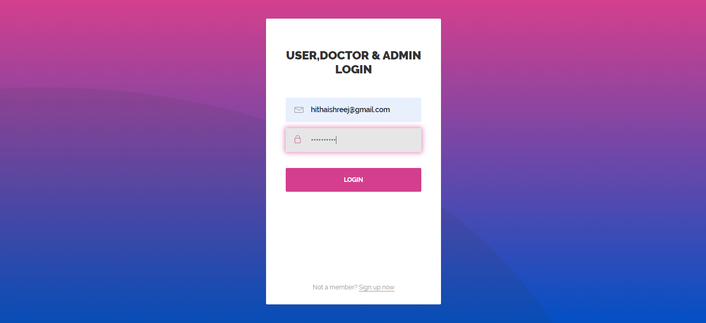

**Home Page :-**

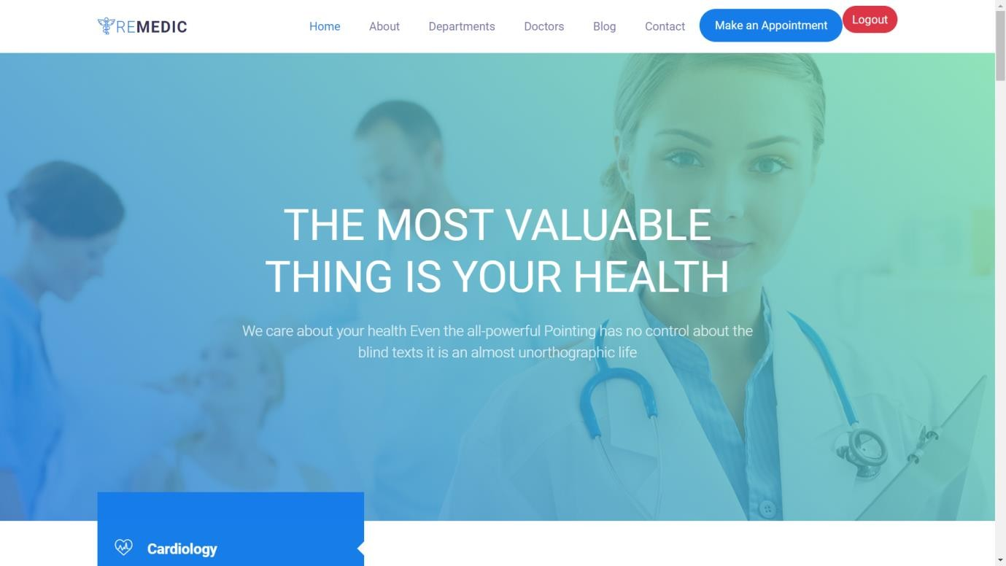

**Home Page:-**

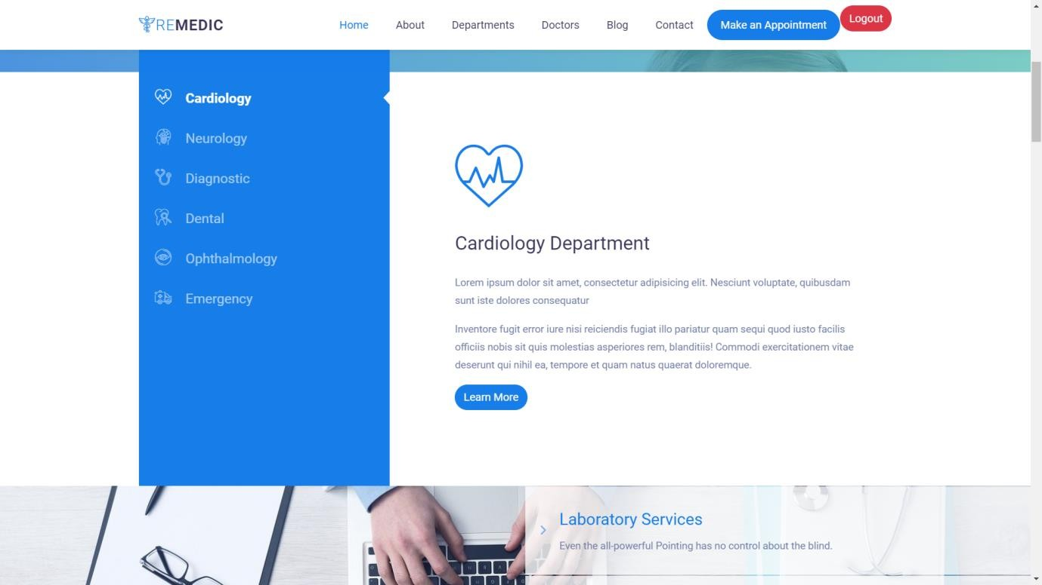

**Home Page:-**

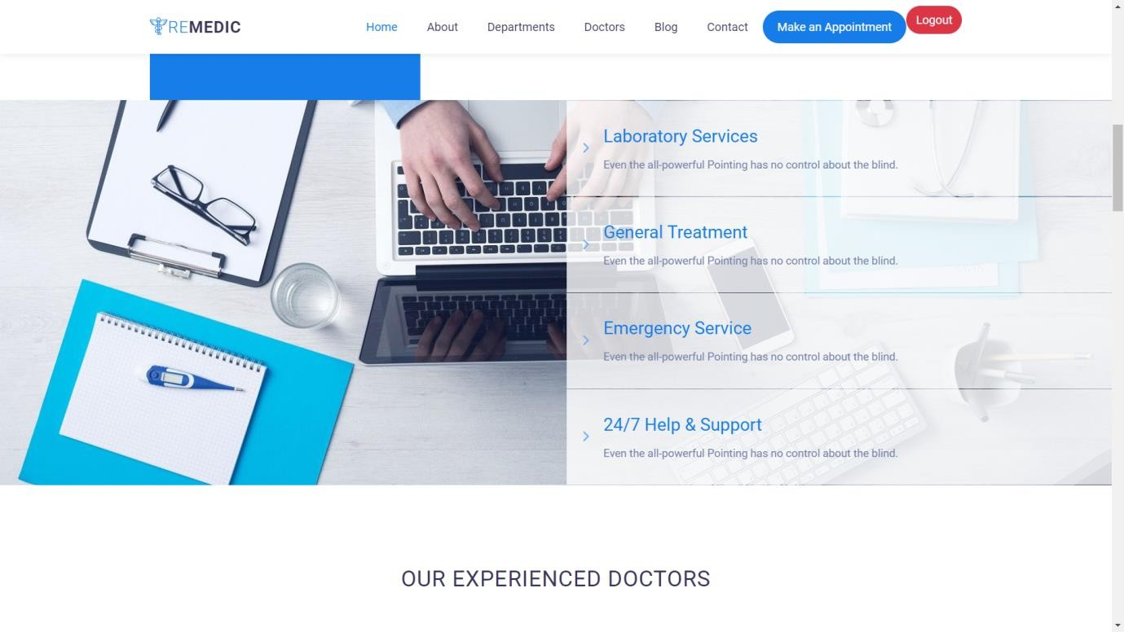

**Home Page:-**

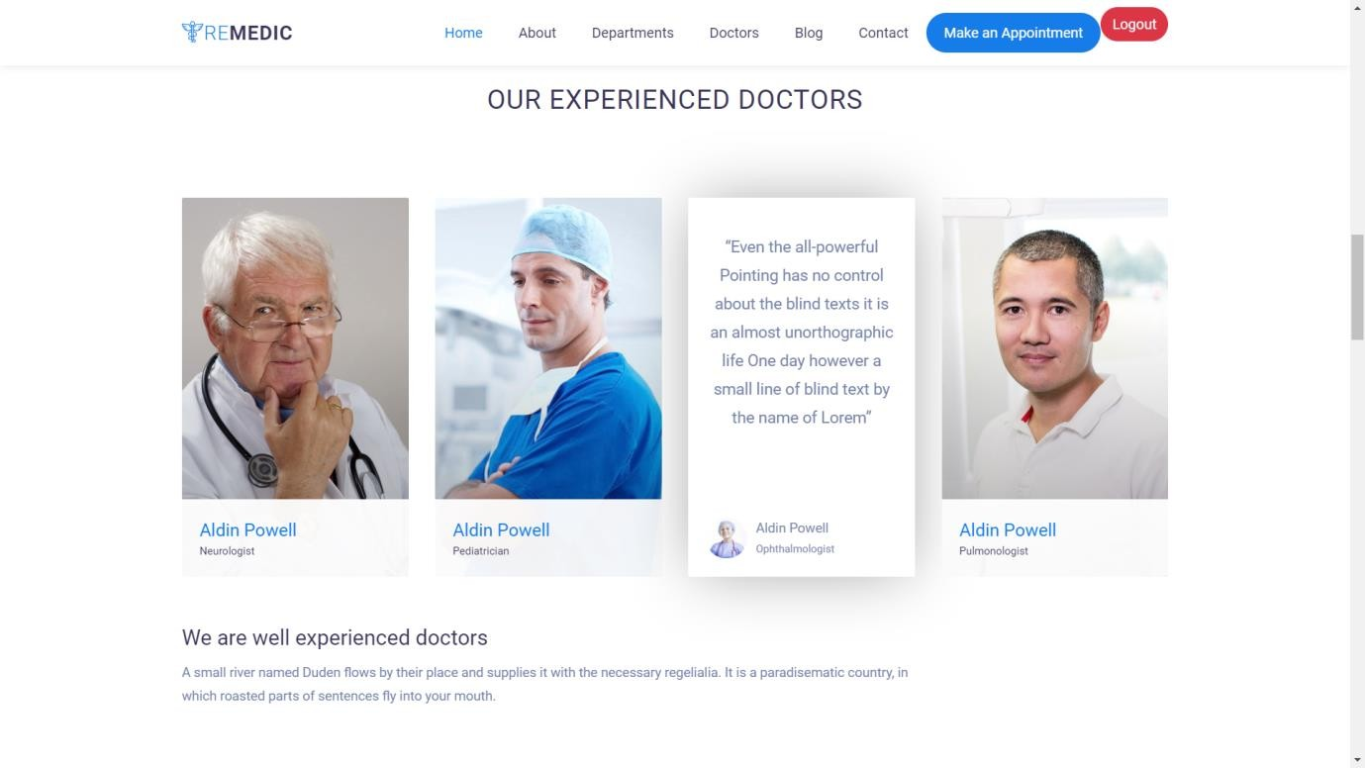

**Home Page:-**

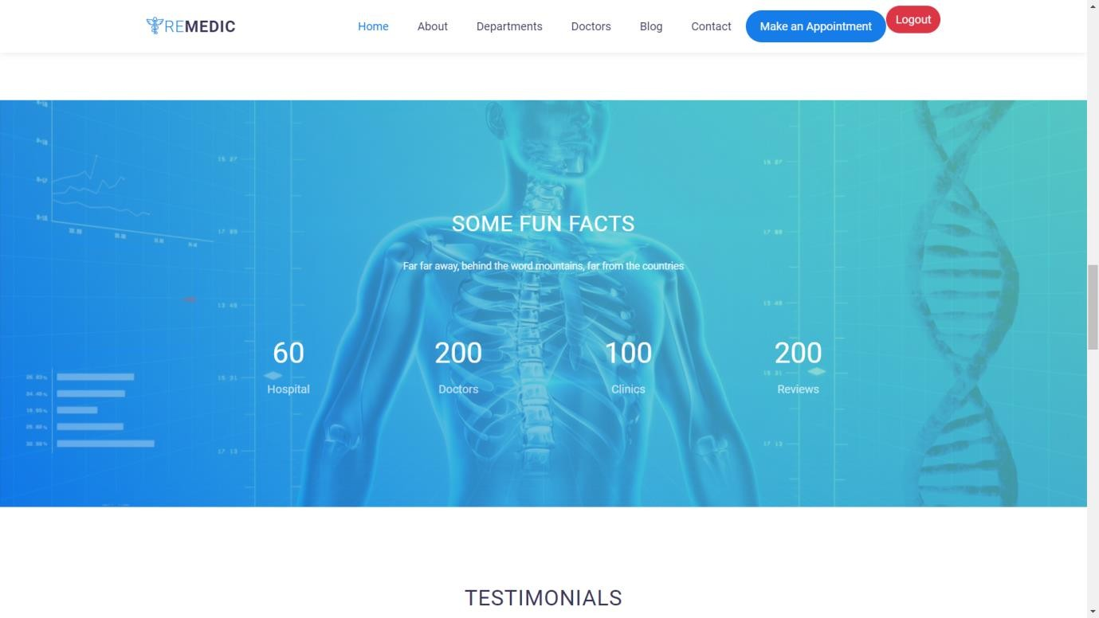

**Home Page:-**

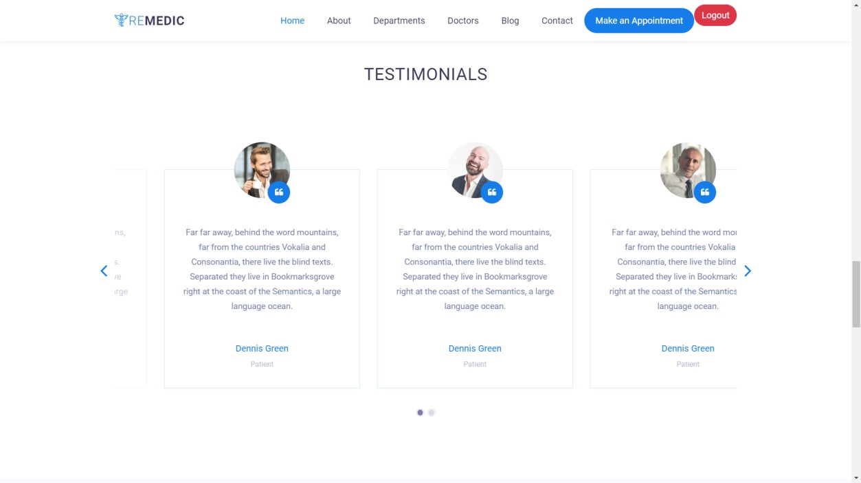

**Home Page:**

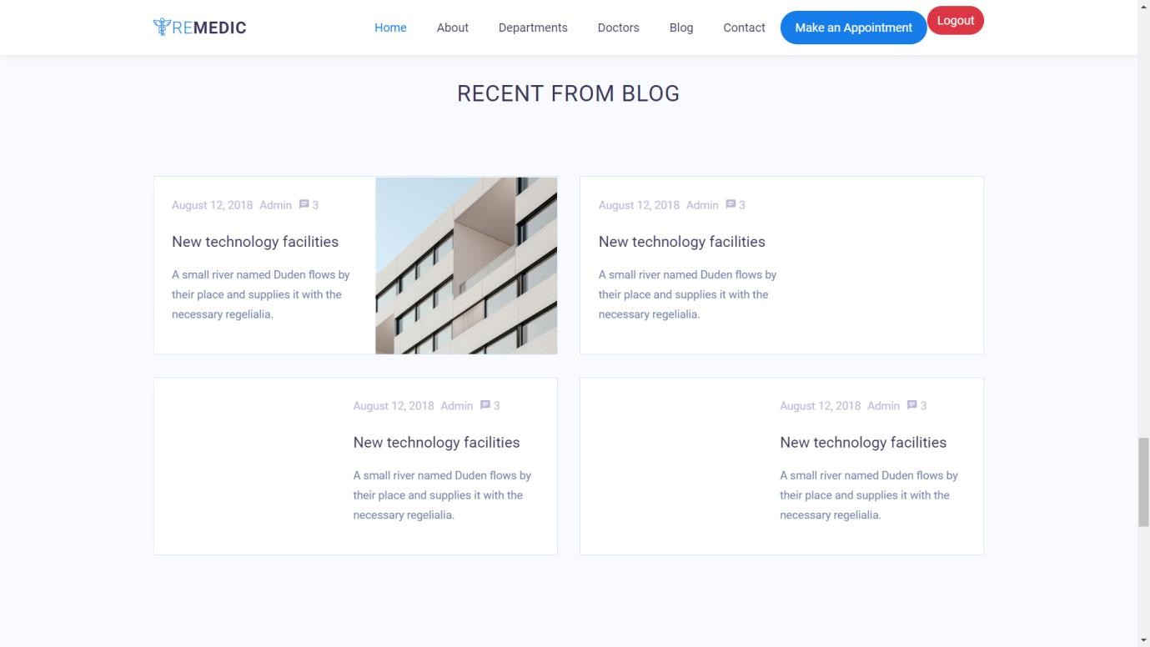

**Doctor Page:-**

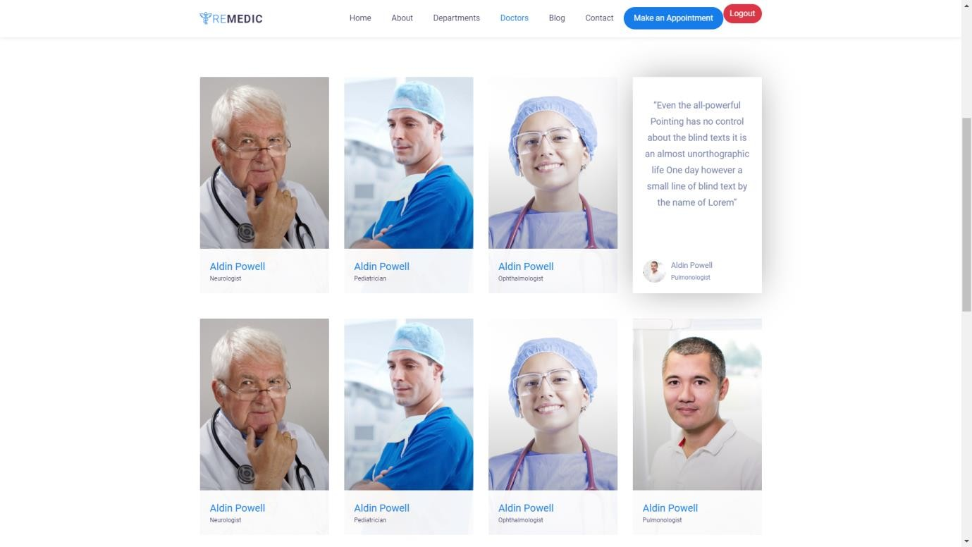

**About Us Page:**

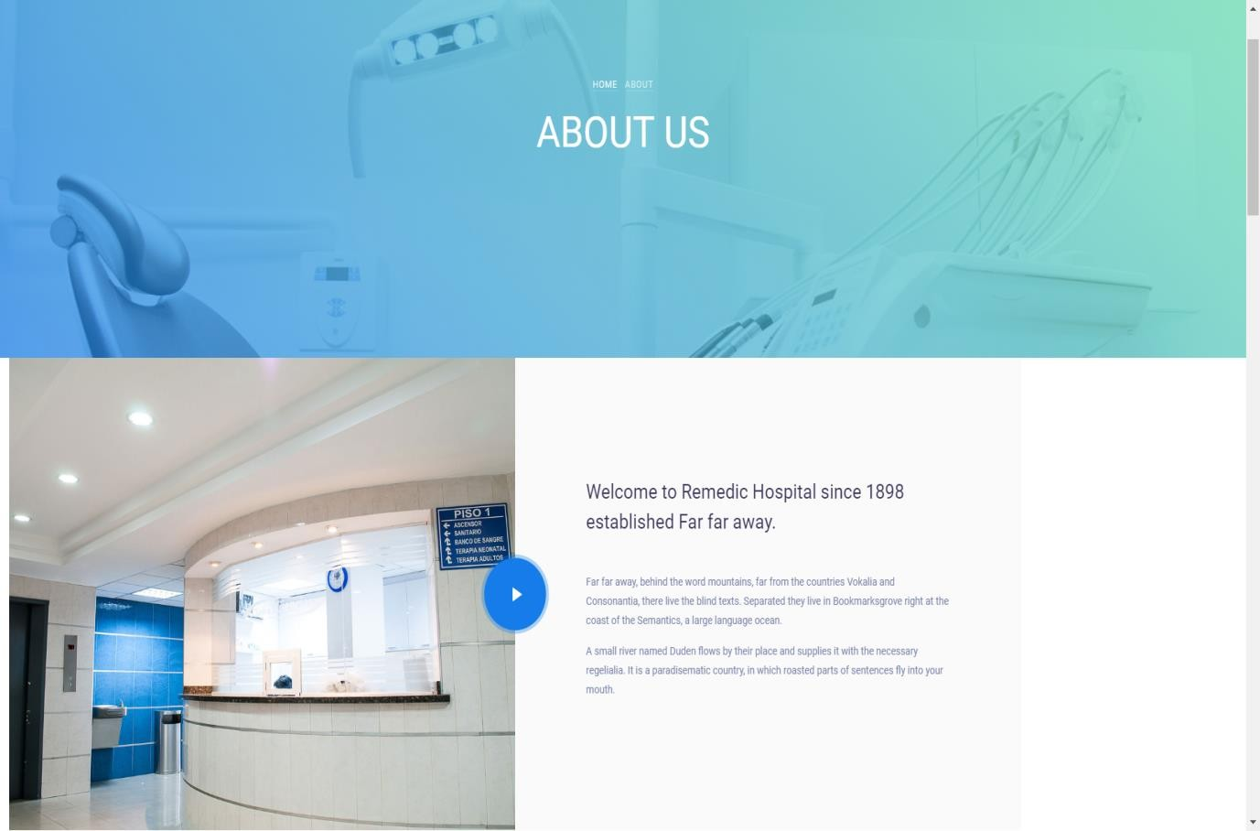

**Blog Page:**

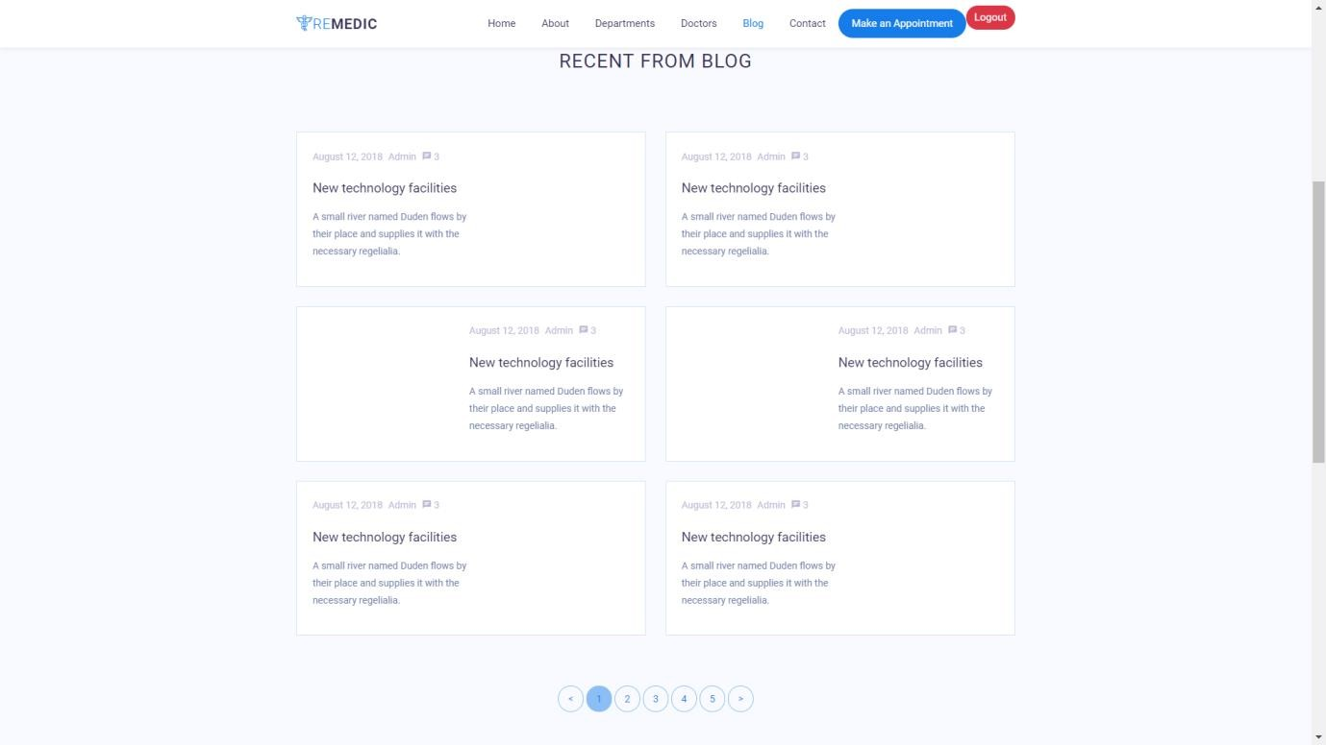

**Appointment Page:**

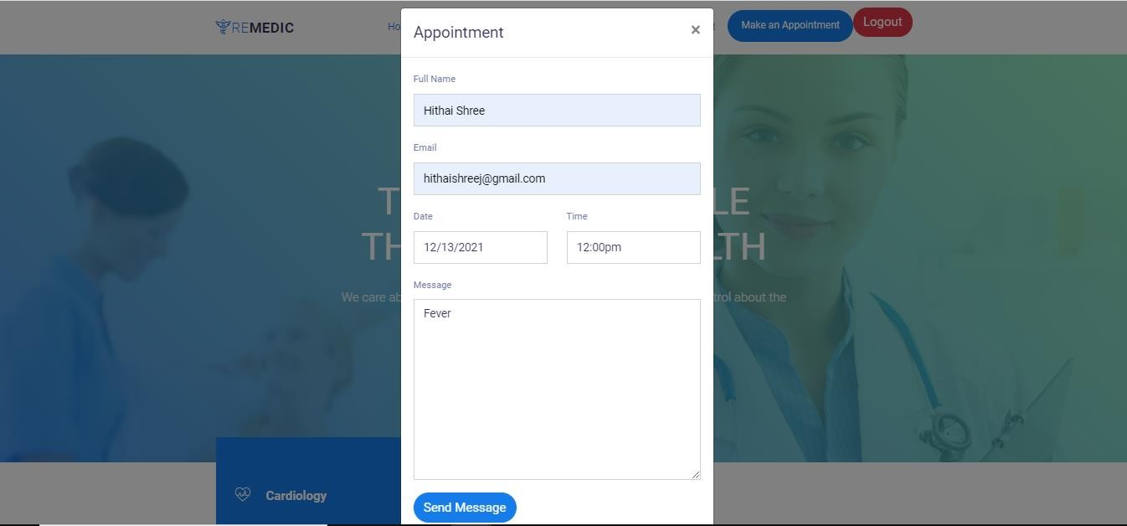

**Doctor Login Page:**

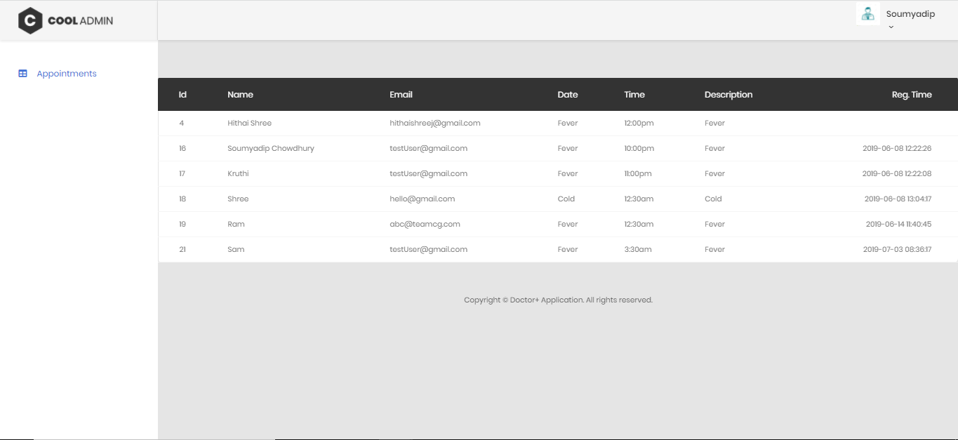

**Doctor Logout Page:**

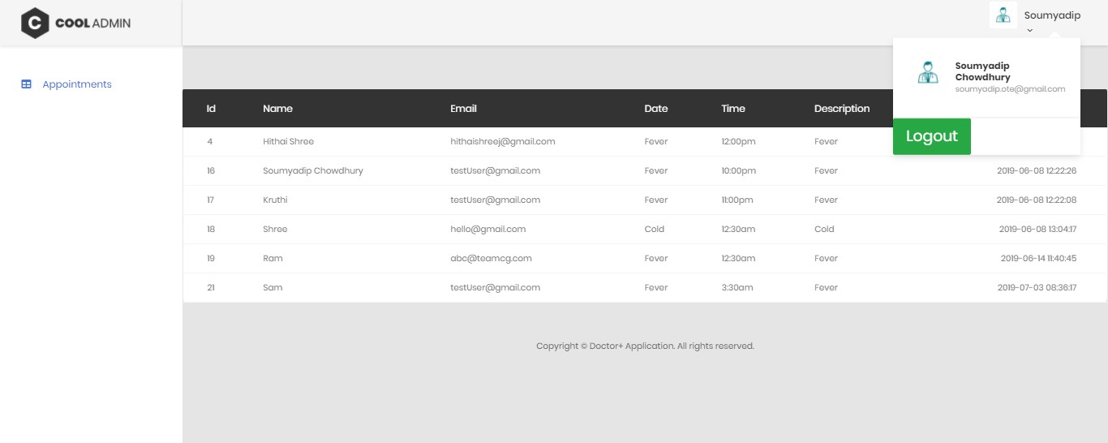

**User Details Page:**

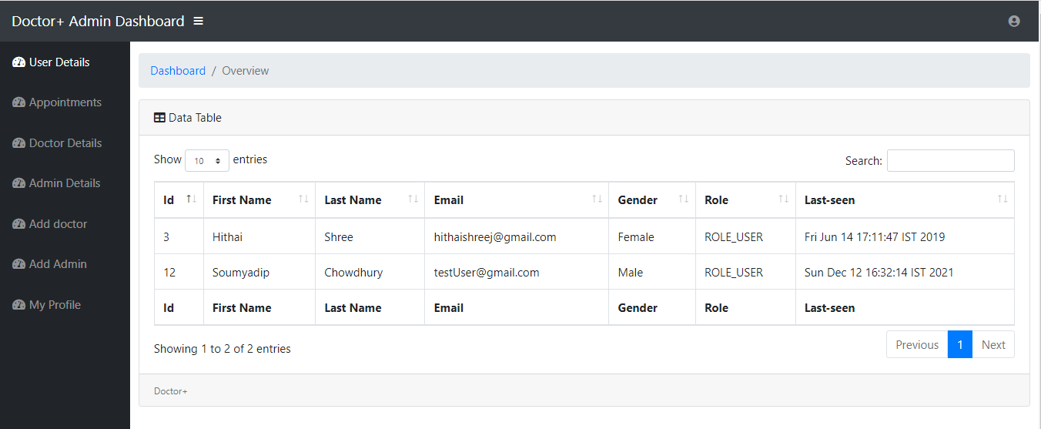

**Appointments Page:**

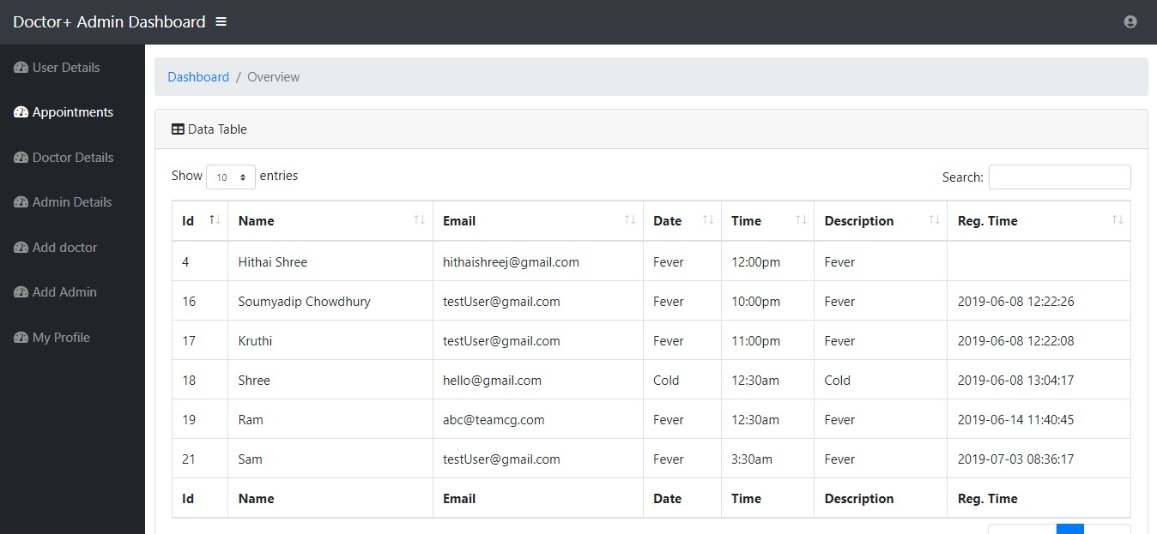

**Doctors Details Page:**

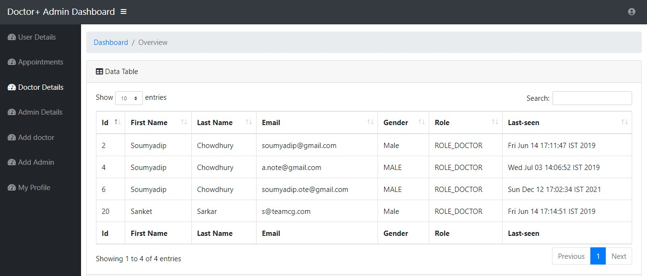

**Admin Details Page:**

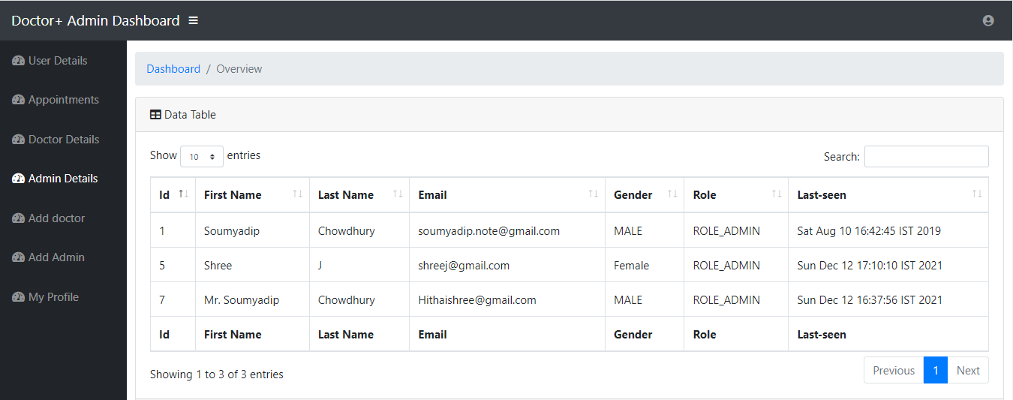

**Add Doctors Page:**

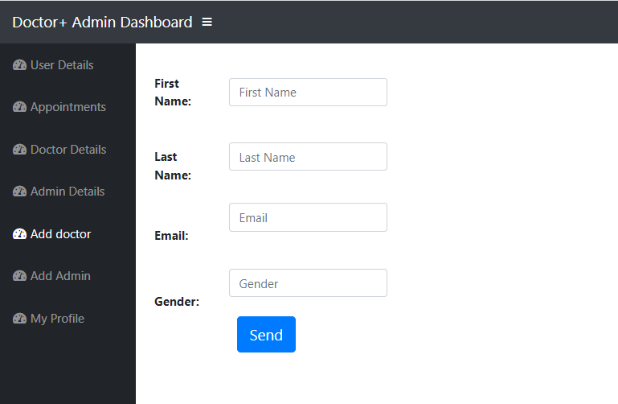

**Add Admin Page:**

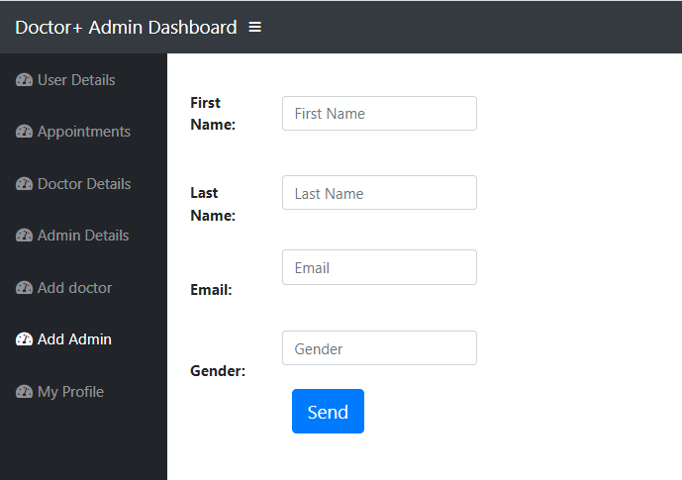

**My Profile Page:**

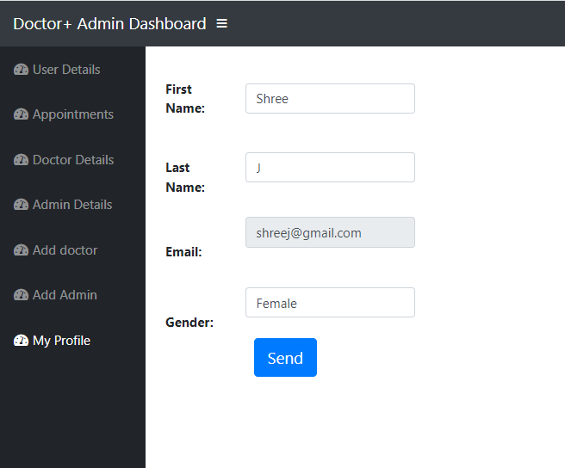

**Logout Page:**

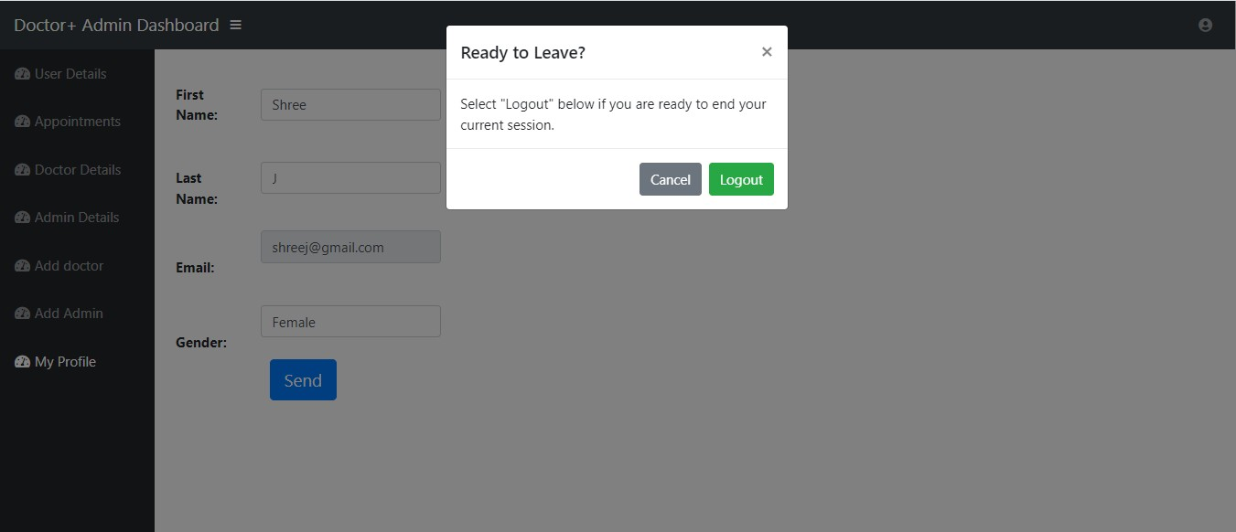

**Advantages:**

**OTHER ASPECTS**

After the customized software is implemented and integrated into the system, patient care and hospital administration becomes an easy job.

1. Makes prescription readable and understandable to patients.
2. Eliminate redundancy in term of data storage. Data will be stored in a computer not heap of files.
3. Reduce the time wasted in retrieving data especially in finding a past health records.
4. Increase Efficiency and Interactivity in any area of specialization in the hospital.
5. Able to quickly collect and edit data,summarize result and adjust as well as collect errors promptly.
6. Uses Bcrypt encoding technique to store passwords hash for secure logins.

**Limitations of the system:**

1. Patients don’t have any role.
2. No Live Queue feature.

### Applications:

1. For small or middle scale hospitals .
2. For managing Queue.

### Future plan:

1. To include Patient module.
2. To manage IPD section.

# Conclusion And Reference

This project helps in making paperless activities. It reduces the workload from Doctor and Receptionist. It provides more ease and flexibility to Doctor, Administrator and Receptionist.

This digitalization has reduced costs of Hospital. This work has created a little awareness and promotes the idea that the concept of paperless office is reality.

## References :-

* <https://www.youtube.com/watch?v=BkRZfxznaOo>
* https:/[/www.youtube.com/watch?v=JR](http://www.youtube.com/watch?v=JR7-EdxDSf0)7[-EdxDSf0](http://www.youtube.com/watch?v=JR7-EdxDSf0)
* https:/[/www.devglan.com/spring](http://www.devglan.com/spring-mvc/storing-hashed-password-database-java)-[mvc/storing-hashed-password-database-java](http://www.devglan.com/spring-mvc/storing-hashed-password-database-java)
* [https://www.freestudentprojects.com/studentprojectreport/projectreport/hospital- management-system-project-report/.](https://www.freestudentprojects.com/studentprojectreport/projectreport/hospital-management-system-project-report/)
* [https://www.academia.edu/7149341/HOSPITAL_MANAGEMENT_SYSTEM_A_PROJ ECT_REPORT_Submitted_in_Partial_Fulfillment_of_the_requirements_for_the_Award_ of_the.](https://www.academia.edu/7149341/HOSPITAL_MANAGEMENT_SYSTEM_A_PROJECT_REPORT_Submitted_in_Partial_Fulfillment_of_the_requirements_for_the_Award_of_the)
* [https://www.academia.edu/7149341/HOSPITAL_MANAGEMENT_SYSTEM_A_PROJ ECT_REPORT_Submitted_in_Partial_Fulfillment_of_the_requirements_for_the_Award_ of_the.](https://www.academia.edu/7149341/HOSPITAL_MANAGEMENT_SYSTEM_A_PROJECT_REPORT_Submitted_in_Partial_Fulfillment_of_the_requirements_for_the_Award_of_the)
* [https://sites.google.com/site/ignoubcafinalyearprojects/project-report/hospital- management-system-project-report.](https://sites.google.com/site/ignoubcafinalyearprojects/project-report/hospital-management-system-project-report)